**VIT BHOPAL UNIVERSITY**

**SCHOOL OF COMPUTING SCIENCE AND ENGINEERING**

DSN-2098 PROJECT EXHIBITION –I

WEEKLY REPORT

Title: Student Information System

Team Members:

1.Dev Mangrani – 21BCE11444

2.Shreya Pandey – 21BCE11376

3.Naman Gupta – 21BCE11213

**II YEAR BTECH (CSE), IIIrd SEMESTER**

**Batch: 2021-2025**

**ABSTRACT**

- Basically this project is about the Student information system.

There will be 2 modules

1. ADMINISTRATIVE MODULE

Student info, hostel info, room info, mess info, health info, hostel employee, complaint, announcement.

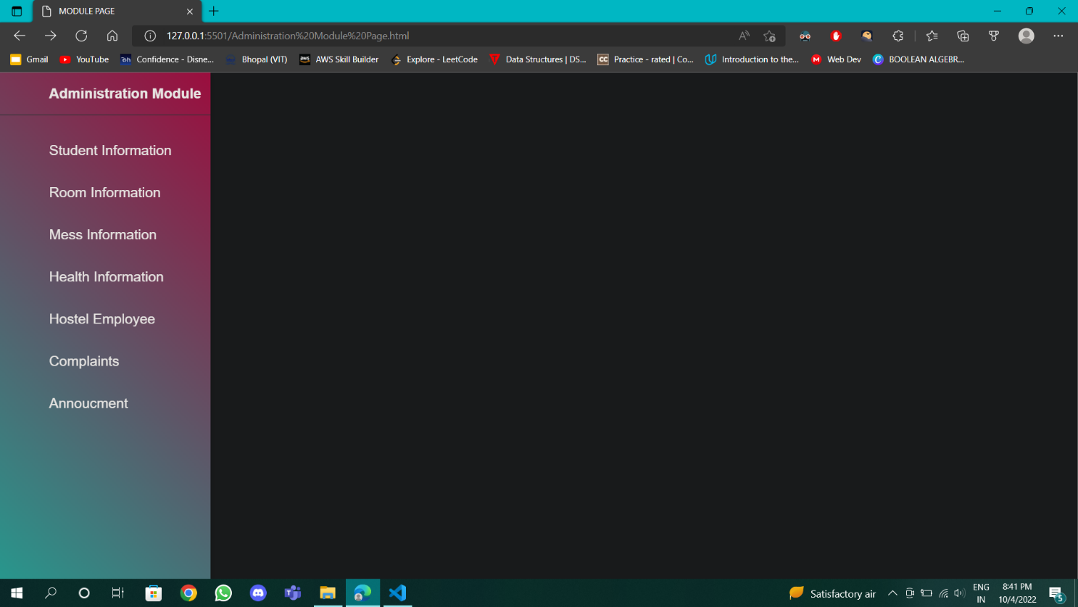

1. STUDENT MODULE

The following details may be asked by them

. Name

. Unique id

. Gender

. Age

. Address

. Parents info

ROOM CHANGING APPLICATION

The following documents are required

. Student name

. Registration number

. Current room no

OUTING APPLICATION

Same points are followed here and some points were added.

. Time he or she leaving

. Visiting address

. Parents info

COMPLAINTS

. It can be related to hostel, mess, medical etc.

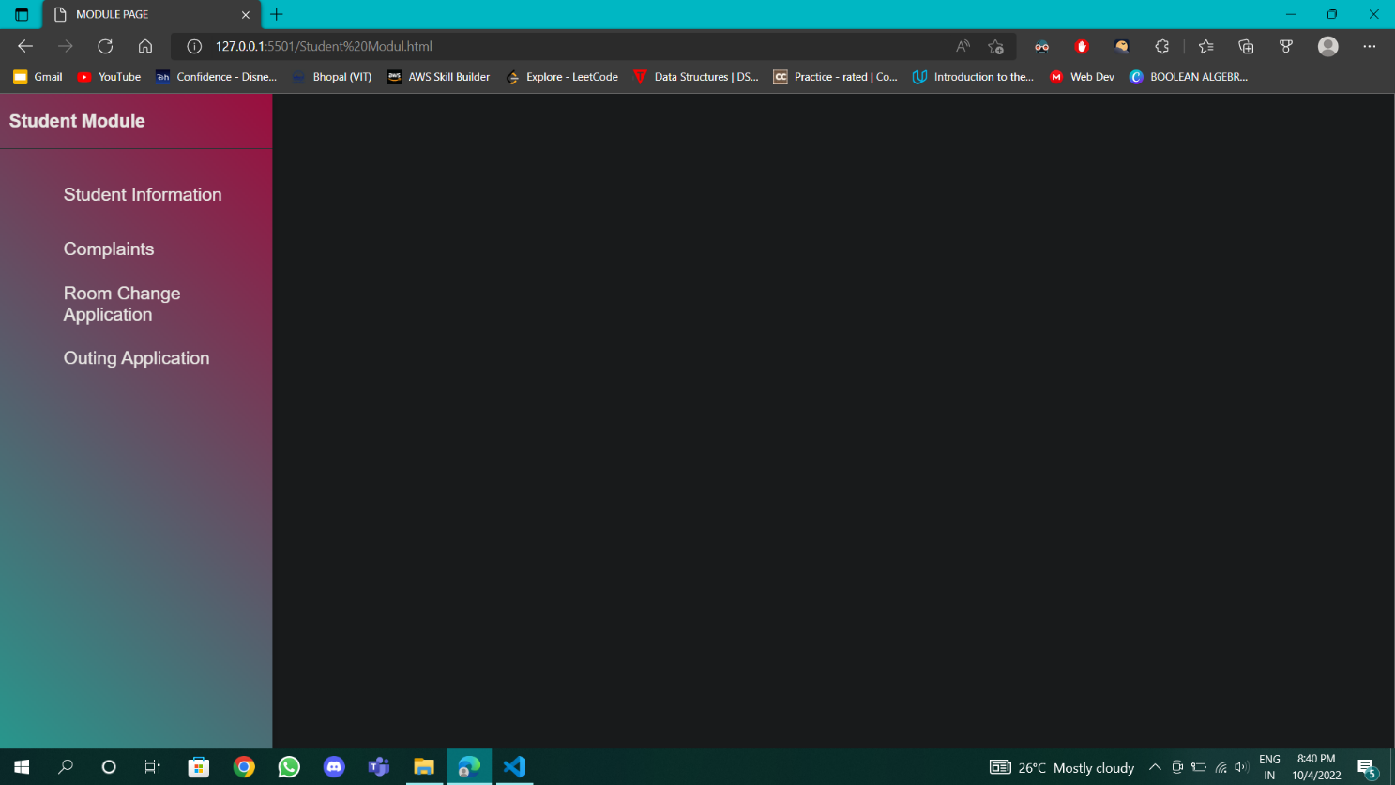

**WEEKLY REPORT**

**From:**21/07/2022 **To:**26/07/2022

**Topic Discussion/Work Done:**

* In this week we did some research on the topic.
* Our research consisted of designing the website and how we will execute it.
* We discussed about the working of website and its features.

**Work Proposed:**

* Sir asked us about the features we are adding to the website.
* He asked what additional features are there other than the basic student information website.
* We said that we are just beginners so we will learn and implement simultaneously.

**Remark:**

**Guide Signature**

**REVIEW COMMENTS**

**Guide:**

**Co Guide:**

**Guide Signature Co Guide Signature**

**WEEKLY REPORT**

**From:**1/08/2022 **To:**07/08/2022

**Topic Discussion/Work Done:**

* In this week we collected information regarding the project.
* We collected the content and also discussed about the implementation part.
* We discussed about the structure of the frontend.

**Remark:**

**Guide Signature**

**REVIEW COMMENTS**

**Guide:**

**Co Guide:**

**Guide Signature Co Guide Signature**

**WEEKLY REPORT**

**From:**8/08/2022 **To:**14/08/2022

**Topic Discussion/Work Done:**

* This week we discussed our project i.e. the website with all our friends and faculty members to get the information we need for website.
* We started coding of the frontend of the website.
* We started coding the home page of the website.

**Remark:**

**Guide Signature**

**REVIEW COMMENTS**

**Guide:**

**Co Guide:**

**Guide Signature Co Guide Signature**

**WEEKLY REPORT**

**From:**15/08/2022 **To:**21/08/2022

**Topic Discussion/Work Done:**

* We coded the destinations part of the website in the home page.
* Also added the services that we are providing in the website.

**Remark:**

**Guide Signature**

**REVIEW COMMENTS**

**Guide:**

**Co Guide:**

**Guide Signature Co Guide Signature**

**WEEKLY REPORT**

**From:**22/08/2022 **To:**28/08/2022

**Topic Discussion/Work Done:**

* In this week we added the options in our website.
* Also added the Annoucment section.

**Work Proposed:**

* Sir asked us whether we will be able to complete the project till the review 3.
* Sir asked about the contribution of each member.
* Sir asked about the additional feature that we are adding in the website.
* Sir also asked about the backend but till then only frontend was made.

**Remark:**

**Guide Signature**

**REVIEW COMMENTS**

**Guide:**

**Co Guide:**

**Guide Signature Co Guide Signature**

**WEEKLY REPORT**

**From:**05/09/2022 **To:**11/09/2022

**Topic Discussion/Work Done:**

* Student profile feature includes information about the particular student – student name , gender, unique Id , address , COVID certification,parents information, Aadhar card, room no of that particular student.
* Hostel info. – In this we are given the options with the types of room we want to accommodate like 2 bedded 3 or 4 etc.
* Room info – a particular student staying in a particular room
* Mess info –in this all the details of mess employee have been recorded and taken care of the mess menu and make sure that the Menu revised in every month.
* We completed code of Frontend.

**Remark:**

**Guide Signature**

**REVIEW COMMENTS**

**Guide:**

**Co Guide:**

**Guide Signature Co Guide Signature**

**WEEKLY REPORT**

**From:**12/09/2022 **To:**18/09/2022

**Topic Discussion/Work Done:**

* In this week we focussed on administration panel.
* Here we completed user queries ,ratings and reviews ,destinations, features and services and also the settings in the admin panel.

**Remark:**

**Guide Signature**

**REVIEW COMMENTS**

**Guide:**

**Co Guide:**

**Guide Signature Co Guide Signature**

**WEEKLY REPORT**

**From:**19/09/2022 **To:**25/09/2022

**Topic Discussion/Work Done:**

* Here we coded the student profile as well as Administration panel.
* Also coded some more backend features like about us page , destinations page , contact us page.
* Now our project is almost completed.

**Remark:**

**Guide Signature**

**REVIEW COMMENTS**

**Guide:**

**Co Guide:**

**Guide Signature Co Guide Signature**